**Website Theme: Seoul Concert Map**

JIN Yuyang 1155128201

**Target audience and purpose:**

Target audience for this website is K-pop fans in China who would like to go to Seoul to watch concert.

Currently, for Chinese K-pop fans, information about Seoul concerts is fragmented and unclear. When people want to watch a Seoul concert, they must spend a lot of time looking around for enormous information, such as venue’s specific location, transportation, ticketing, accommodation, etc. More importantly, until the end, they may not be able to obtain correct and comprehensive information.

Therefore, I want to build a website based on concert venues, providing all valid information of related aspects that people need for their concert journey to Seoul. Main purpose for this website is to help people better plan and arrange their trips, first finding venue conveniently and enjoy concert itself, then having a great time in Seoul.

**User journey**

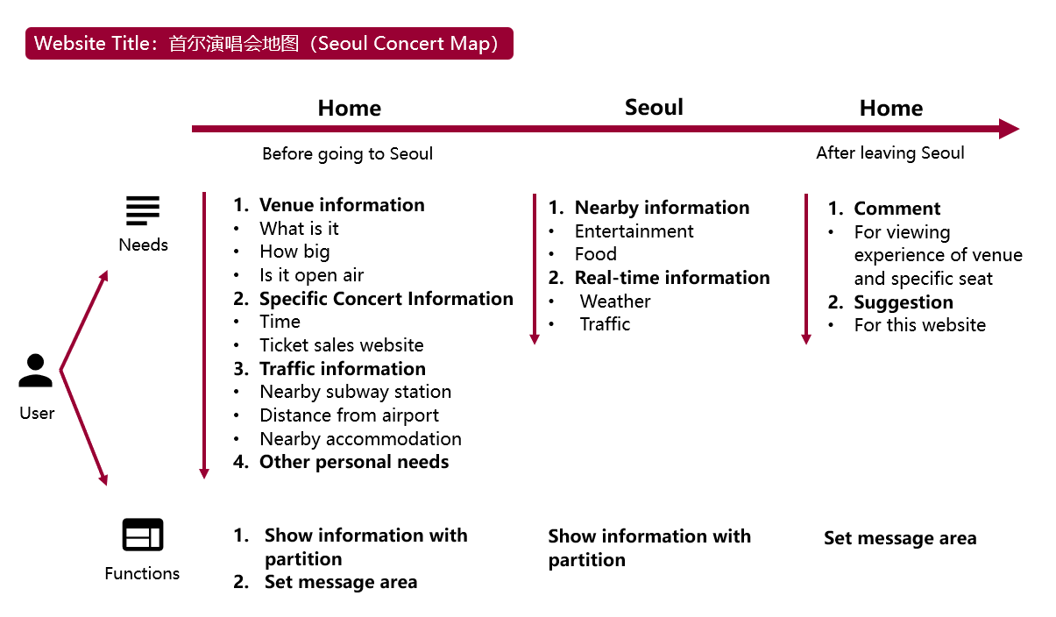

This website will mainly provide information needed in the first two phases: before and during the trip. I will collect data, arrange functional areas and prepare useful content according to user journey. After that, I will consider more about computational and design issues.